# Relational Database

## Relational Database Design

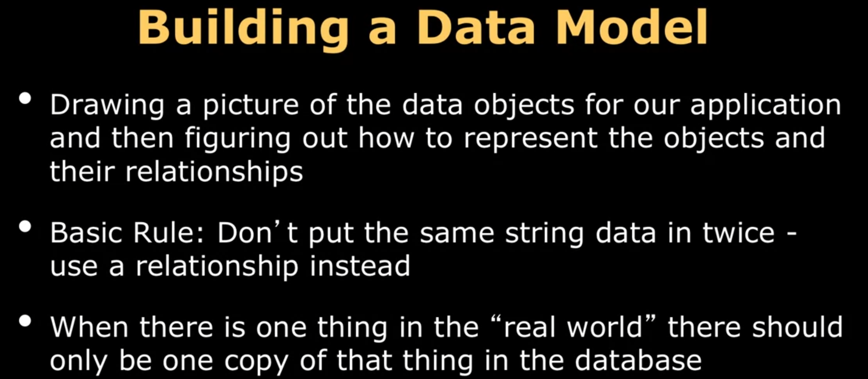

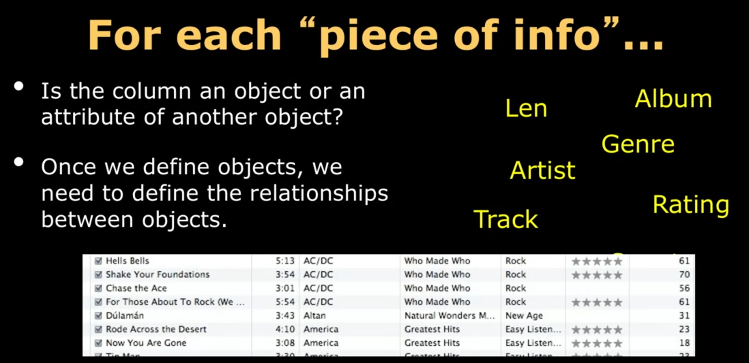

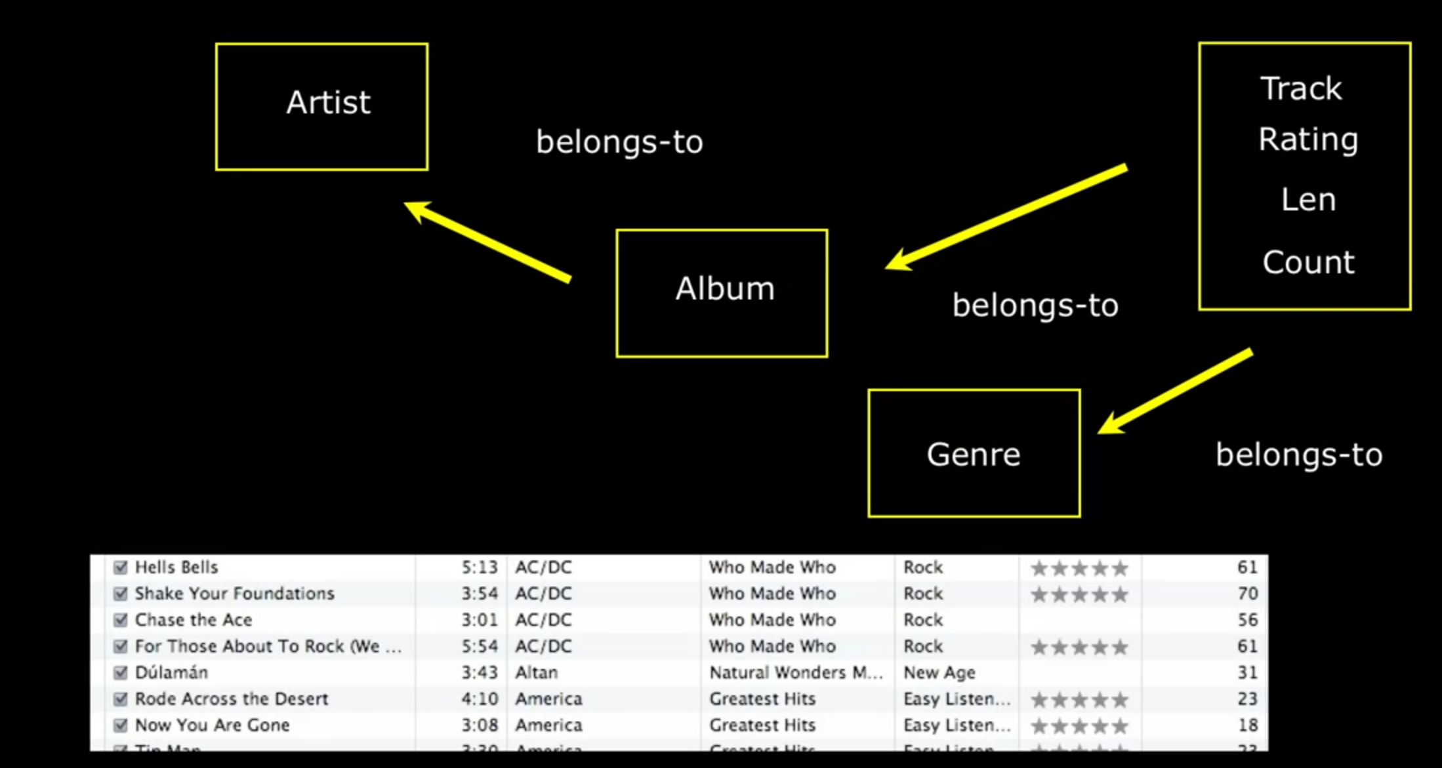

## Keys in Relational database

There are three types of keys in relational database

1. **Primary key:** generally, an integer auto-increment field
2. **Logical key:** what the outside world uses for lookup
3. **Foreign key:** generally, an integer key pointing to a row in another table

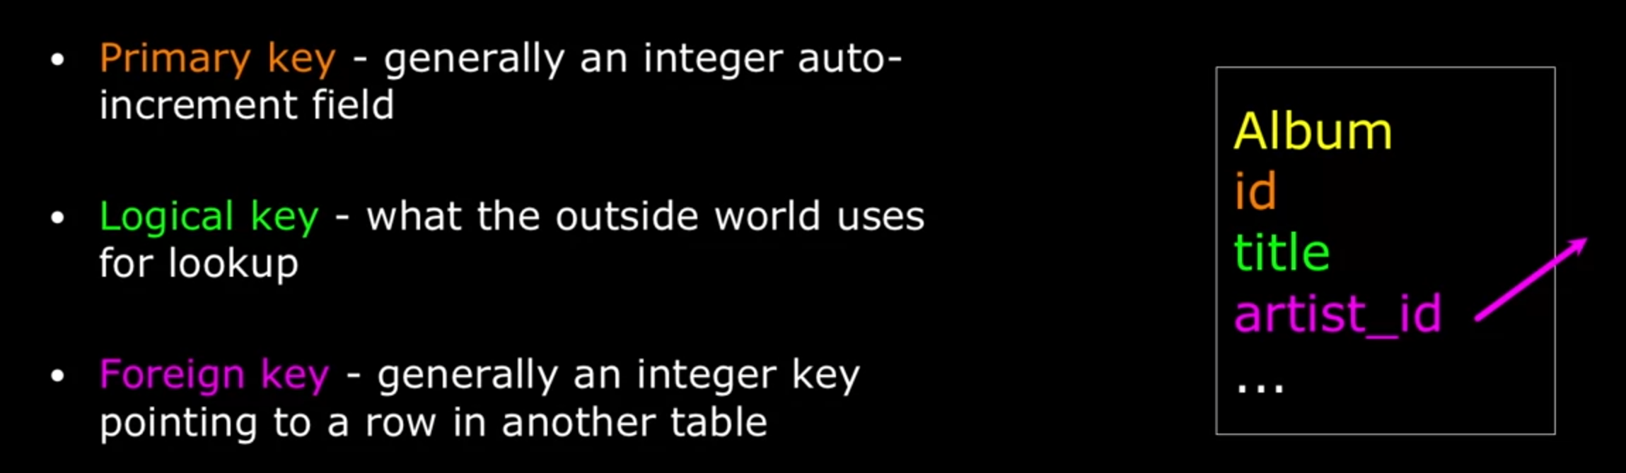

### Naming convention

1. ID are most commonly used primary key
2. For foreign key, use “tableName_fieldName” to name it

### Primary key rules

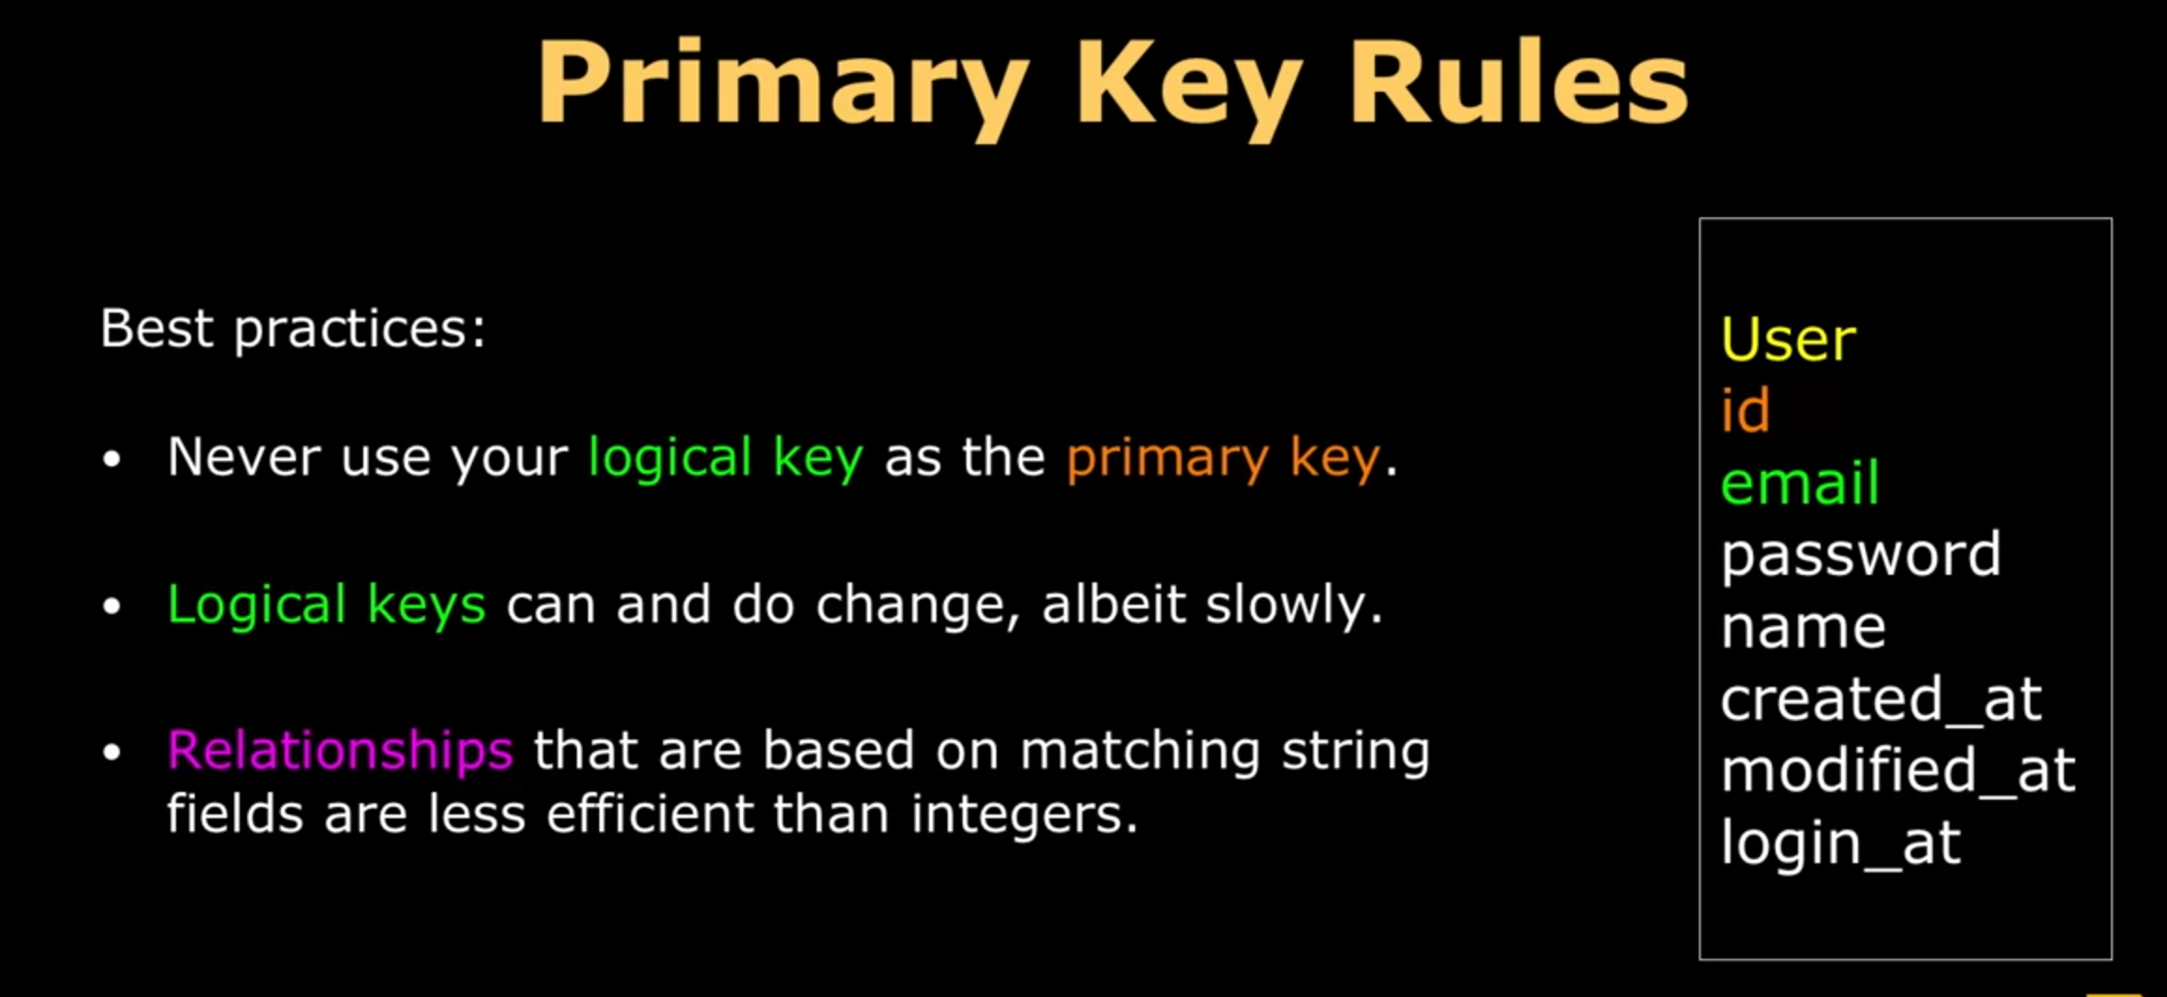

### Foreign key rules

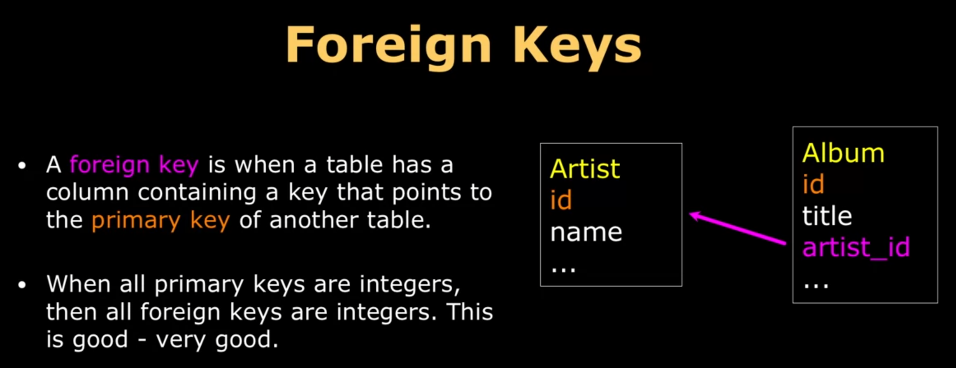

## Database normalization

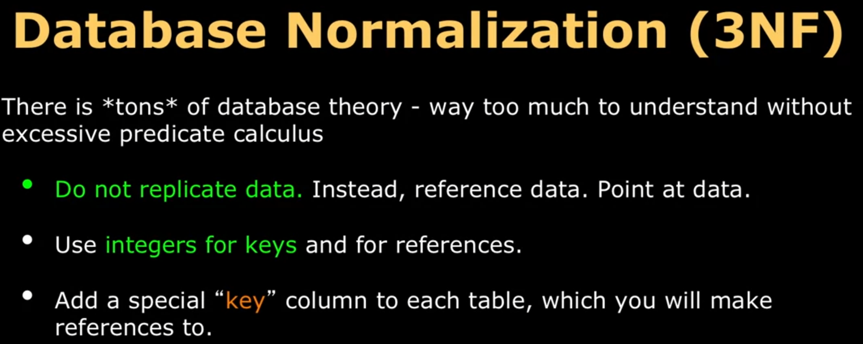

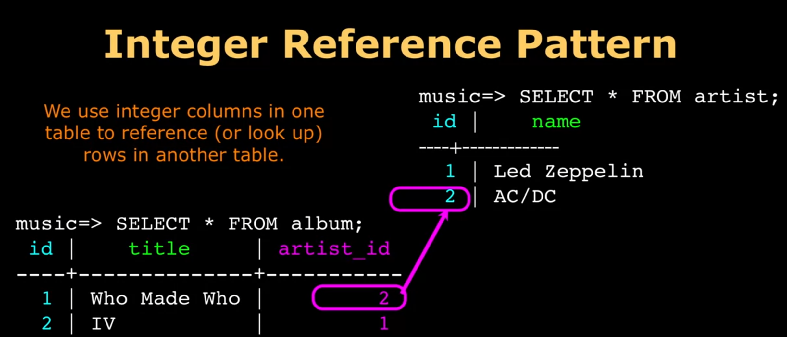

**For the relationship “belongs-to”, we use foreign key to represent it.**

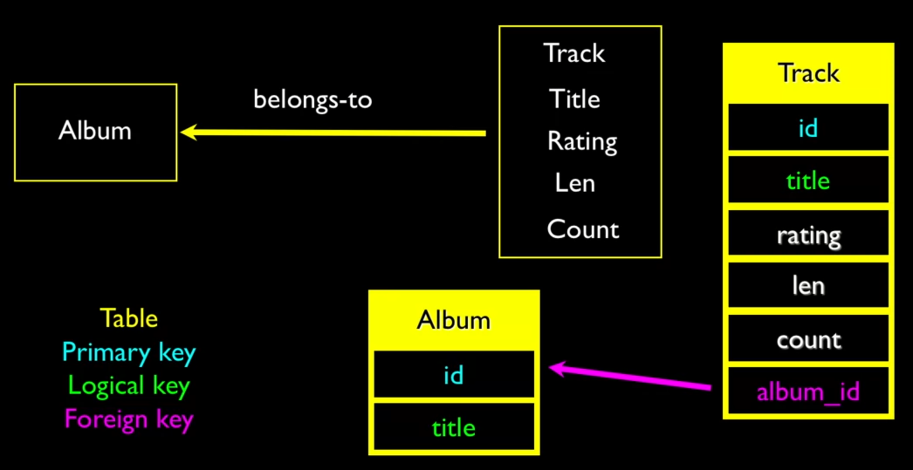

## Examples

### Creating our Music database

Sudo -u postgres psql postgres

Postgres = # CREATE DATABASE music WITH OWNER ‘pg4e’ ENCOING ‘UTF8’;

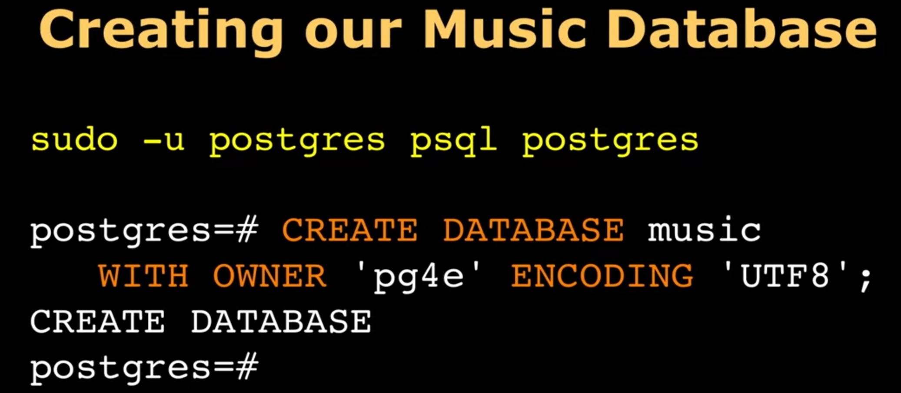

### Create tables

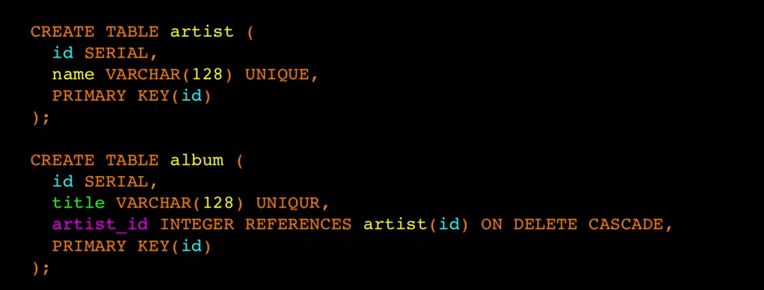

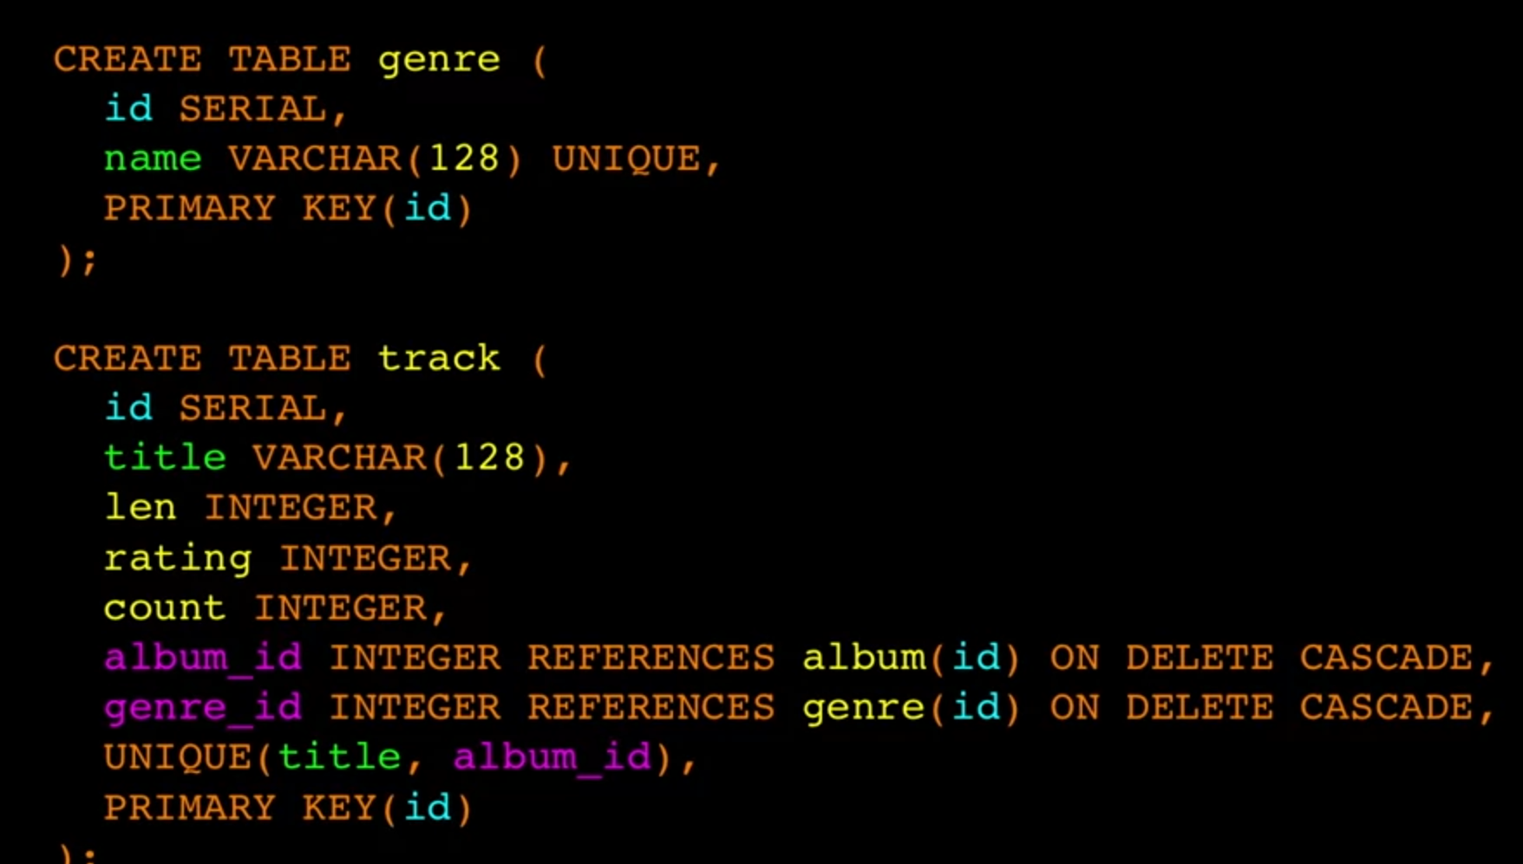

### Insert data

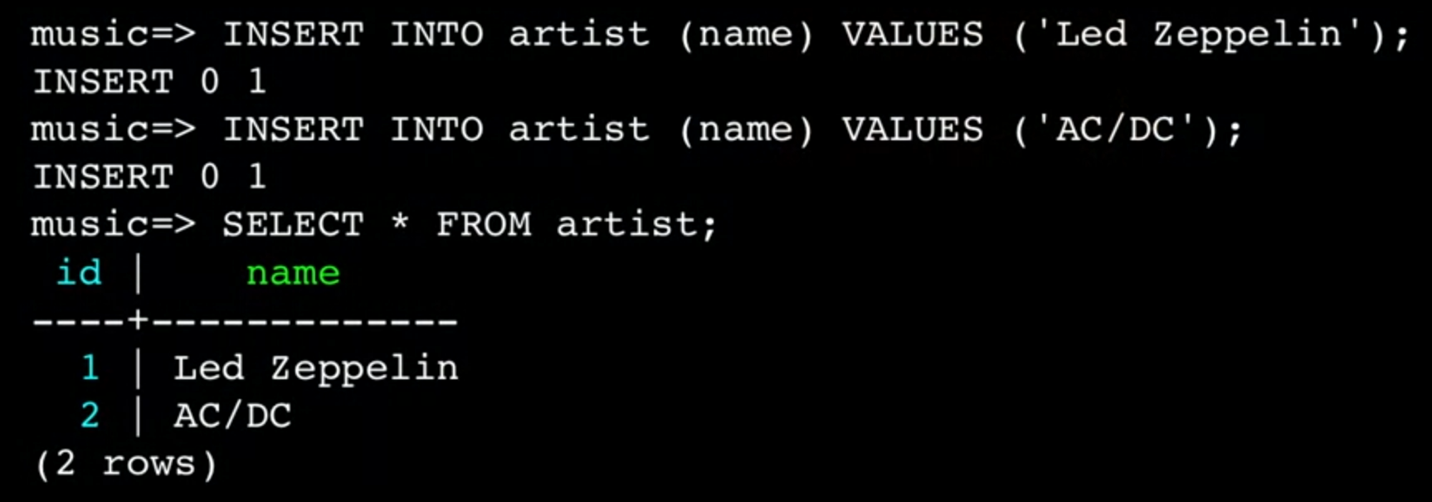

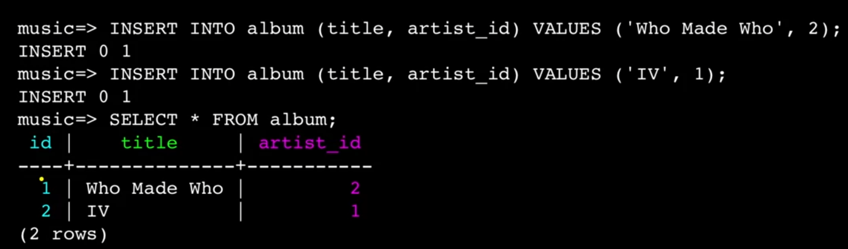

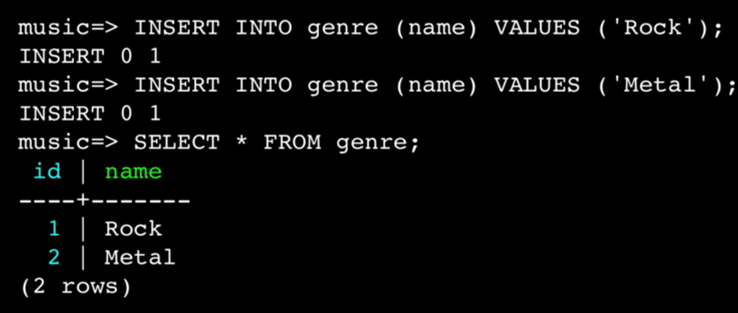

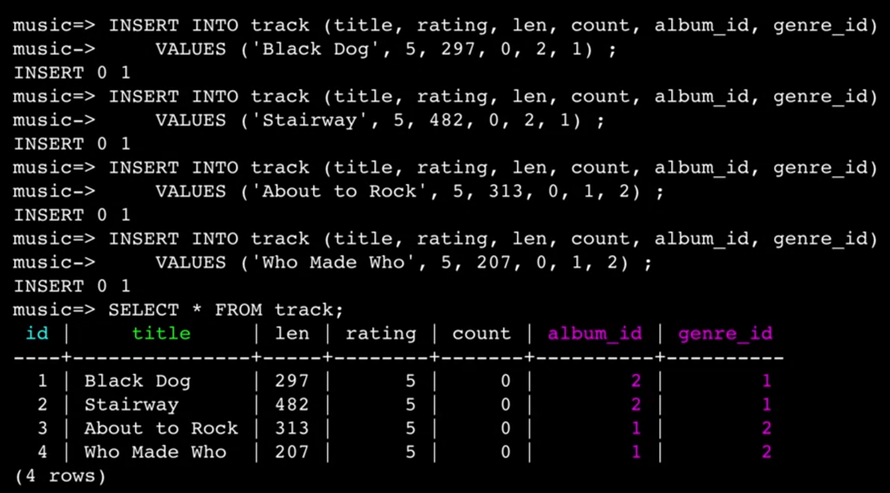

### ON DELETE CASCADE

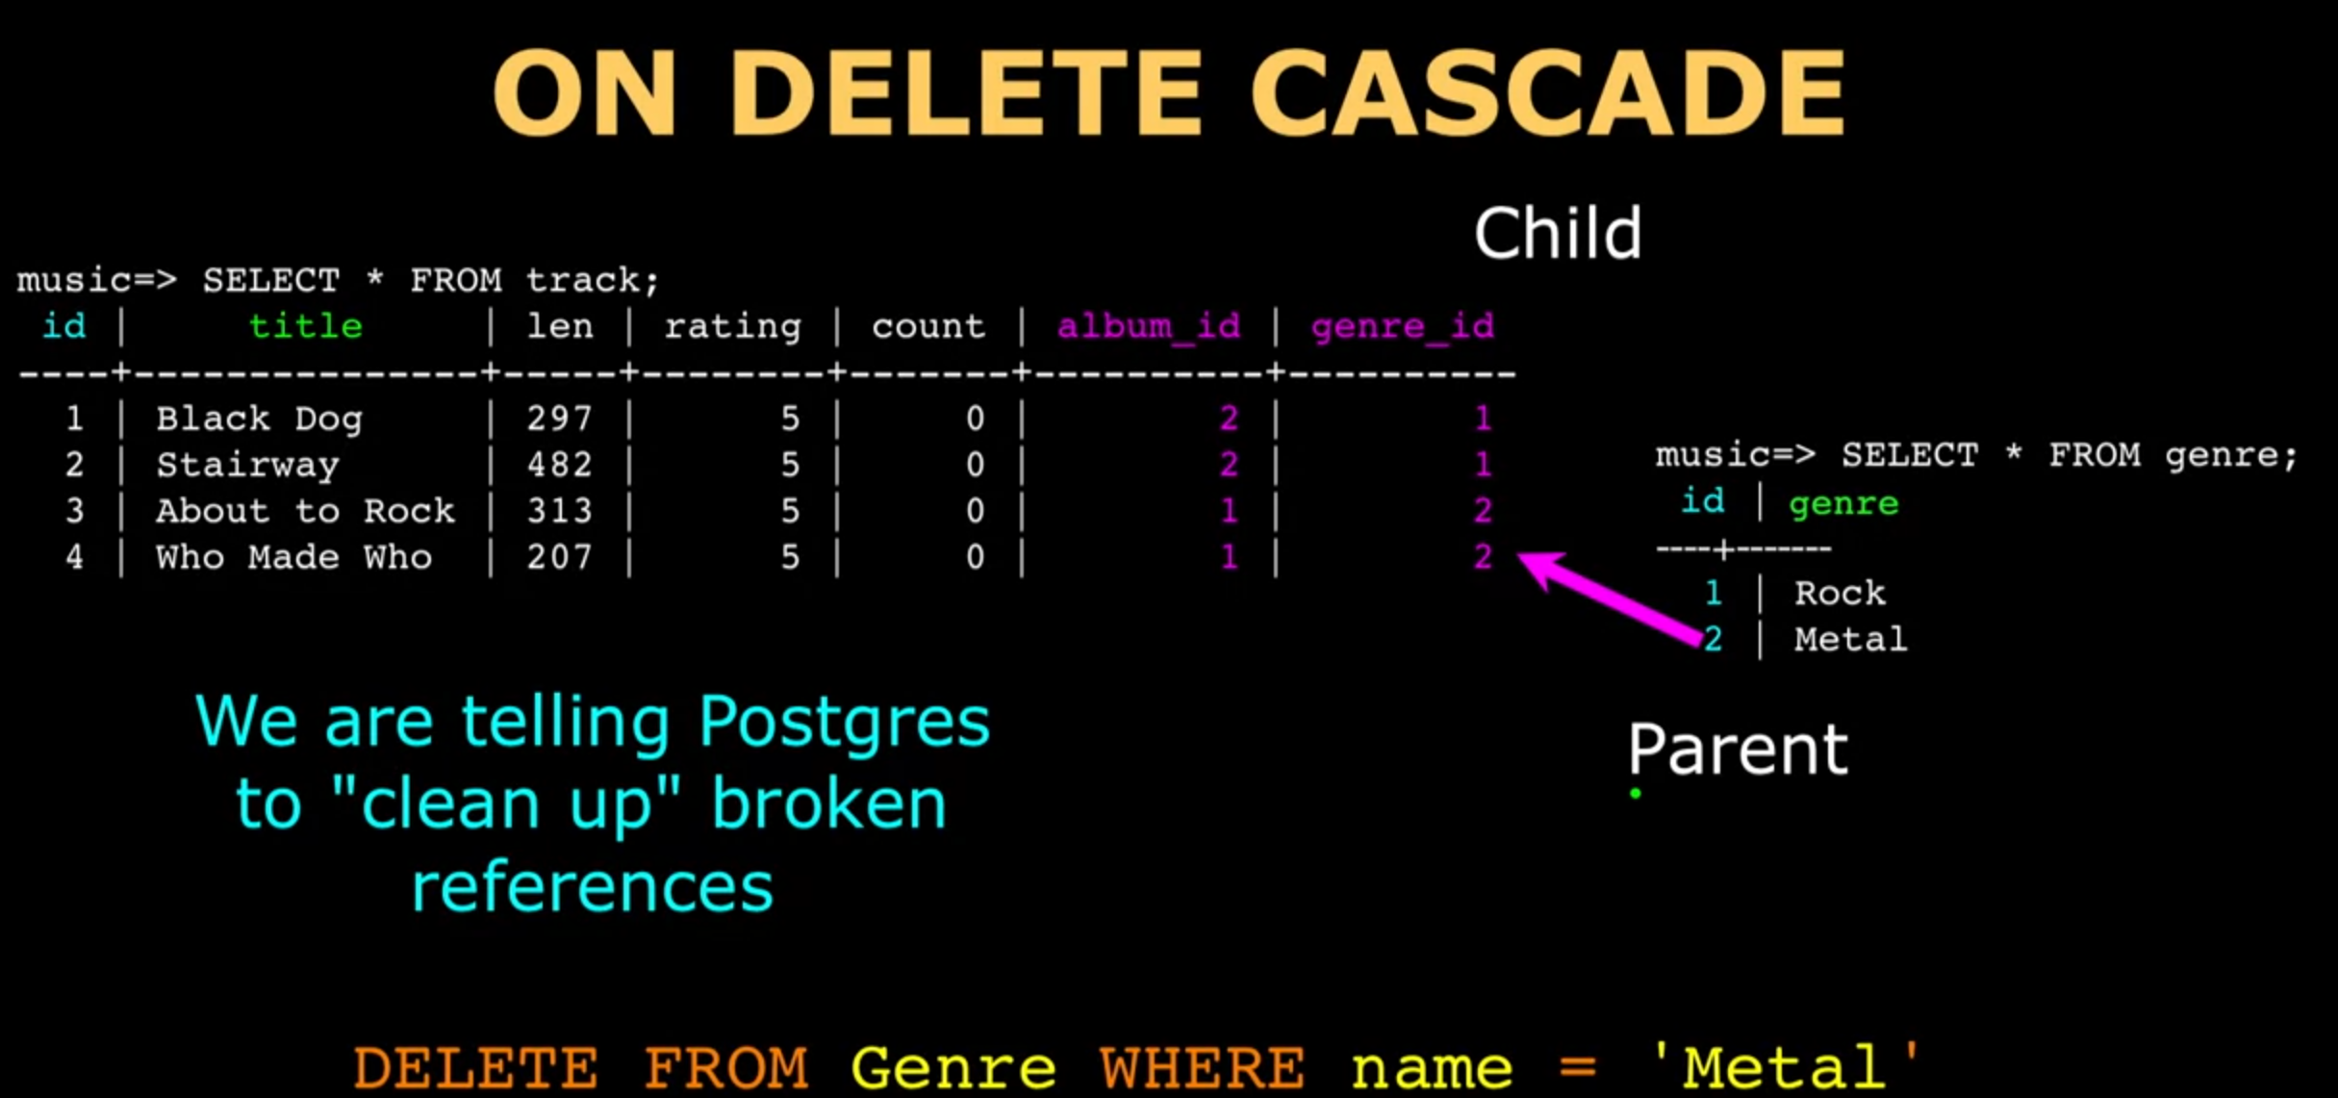

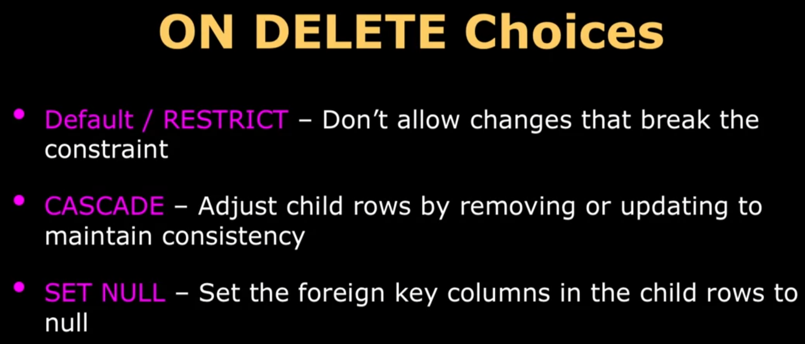

### Using JOIN Across Tables

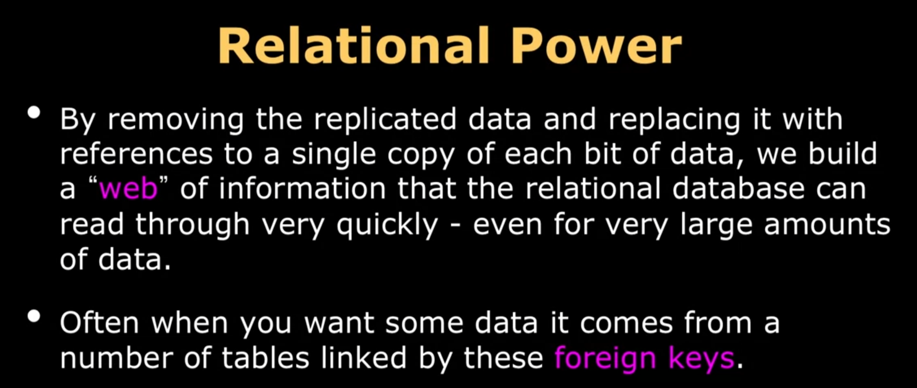

#### JOIN



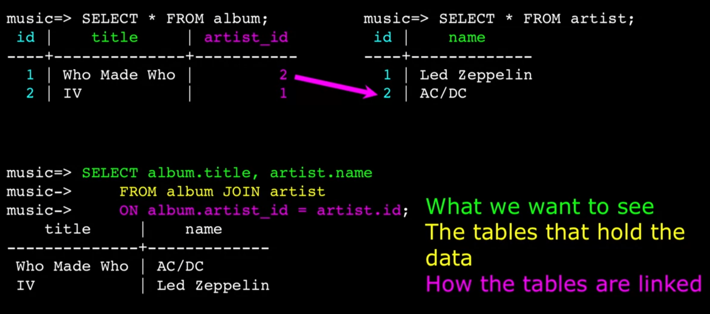

#### INNER JOIN

Join when it matches

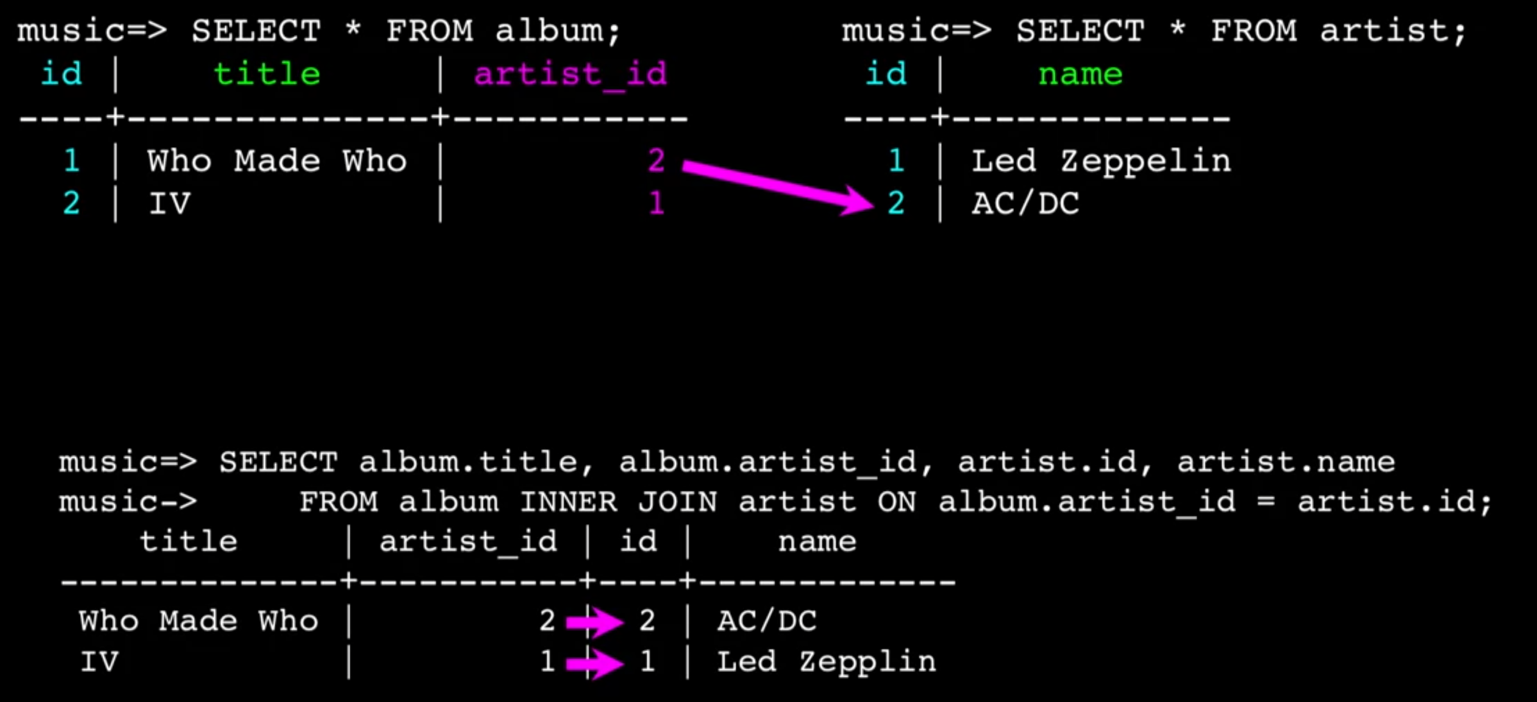

#### CROSS JOIN

Join every possible combination 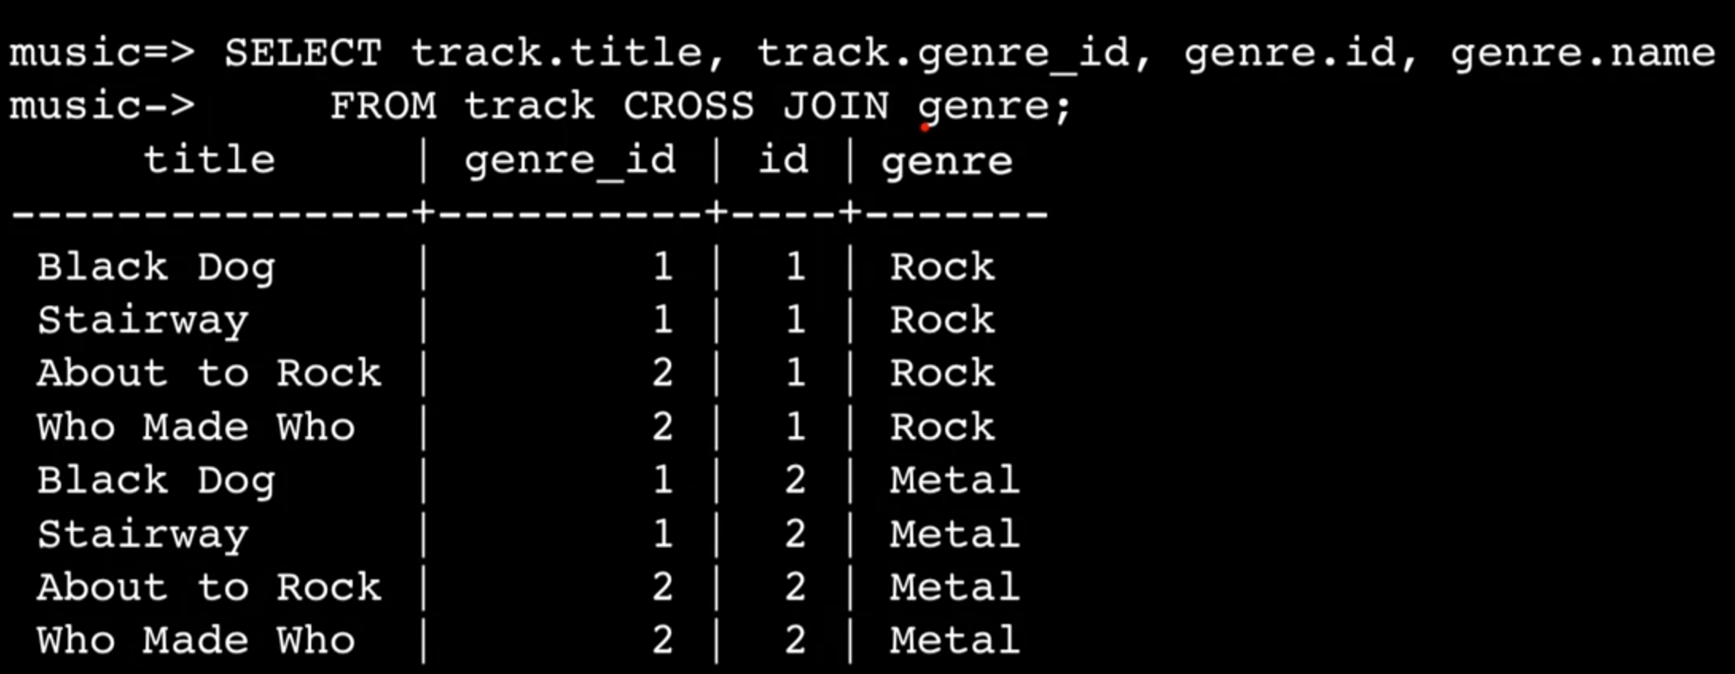 Complex example